1 INTRODUCTION

* 1. Overview

Video game sales analysis is the process of collecting and analyzing data about the sales of video games in order to understand market trends and consumer behavior. This type of analysis can be useful for a variety of purposes, including identifying the most popular games and genres, predicting future sales, and developing marketing strategies. Video game sales analysis typically involves collecting data from Kaggle sources. It was generated by a scrape of vgchartz.com. This data may include information about the number of units sold, the retail price, and the platforms on which the games are played. Video game sales analysis may be conducted by game developers, publishers, retailers, and other industry professionals. It is an important part of the video game industry, as it helps to understand the needs and preferences of consumers and to identify opportunities for growth and innovation. Analysing sales data from more than 16,500 games. This dataset contains a list of video games with sales greater than 100,000 copies. It was generated by a scrape of vgchartz.com.

1.2 Purpose

Business requirements for analyzing video game sales would include data on the sales of specific video games, information on the gaming industry as a whole, and data on consumer demographics and purchasing habits. Additionally, it's also important to have information on platform sales, region, and competition in the market. Increased social interaction and connection through online multiplayer gaming. Increased awareness and representation of diverse groups in the gaming industry. Increased accessibility to gaming through mobile and online platforms. Increased use of gaming as a form of therapy or rehabilitation. Increased revenue for the gaming industry. Increased competition among game developers and publishers. Increased investment in research and development for new technologies and platforms. Increased use of data analytics to track player behaviour and improve game design. Increased use of microtransactions and in-game purchases for additional revenue streams.

2 Problem Definition & Design Thinking

* 1. Empathy Map

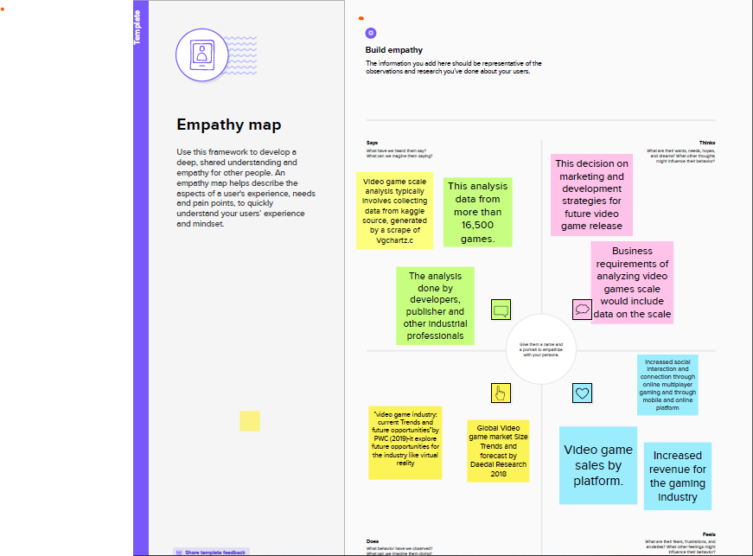

* 1. Ideation & Brainstorming map screenshot

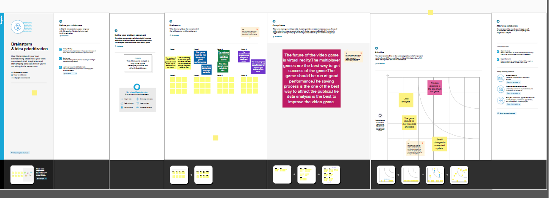

1. RESULT

3.1 DASHBOARD

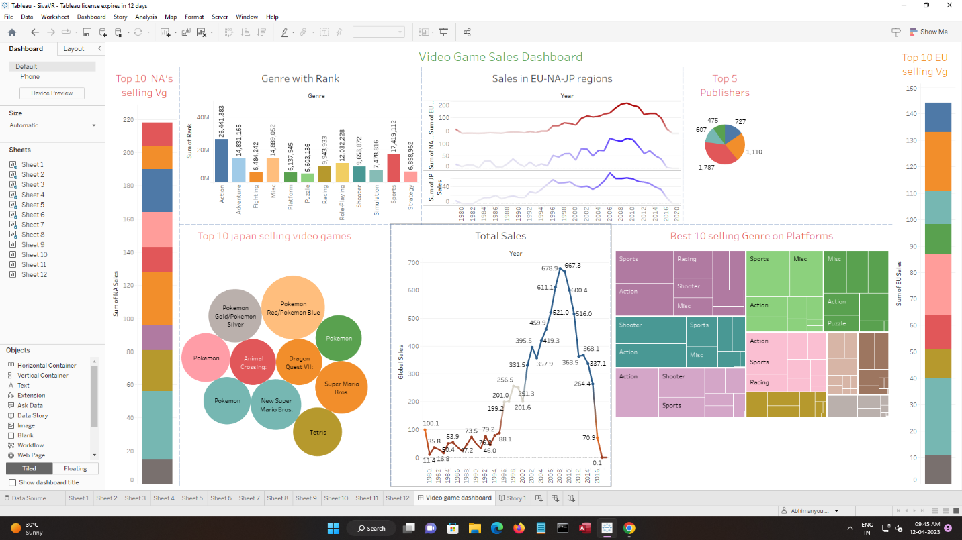

3.2 STORY

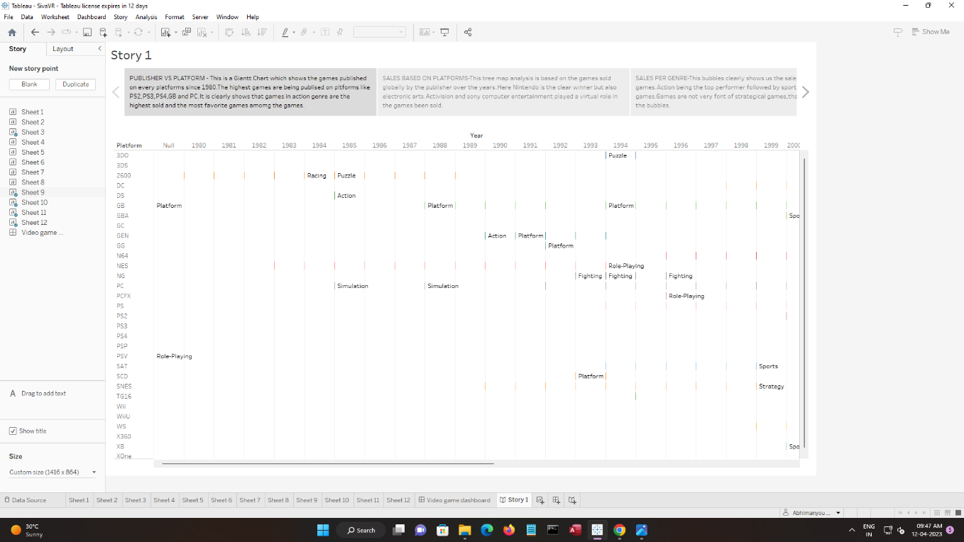

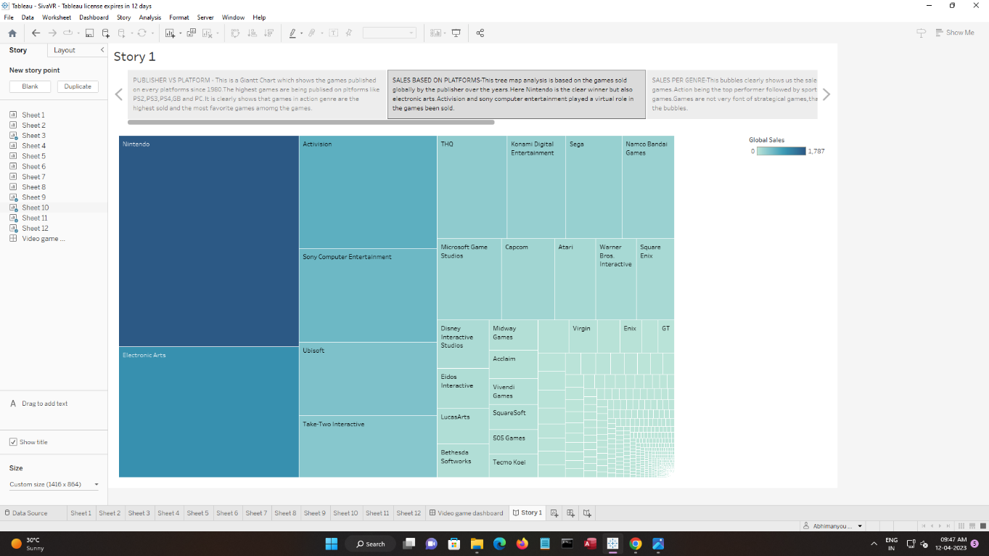

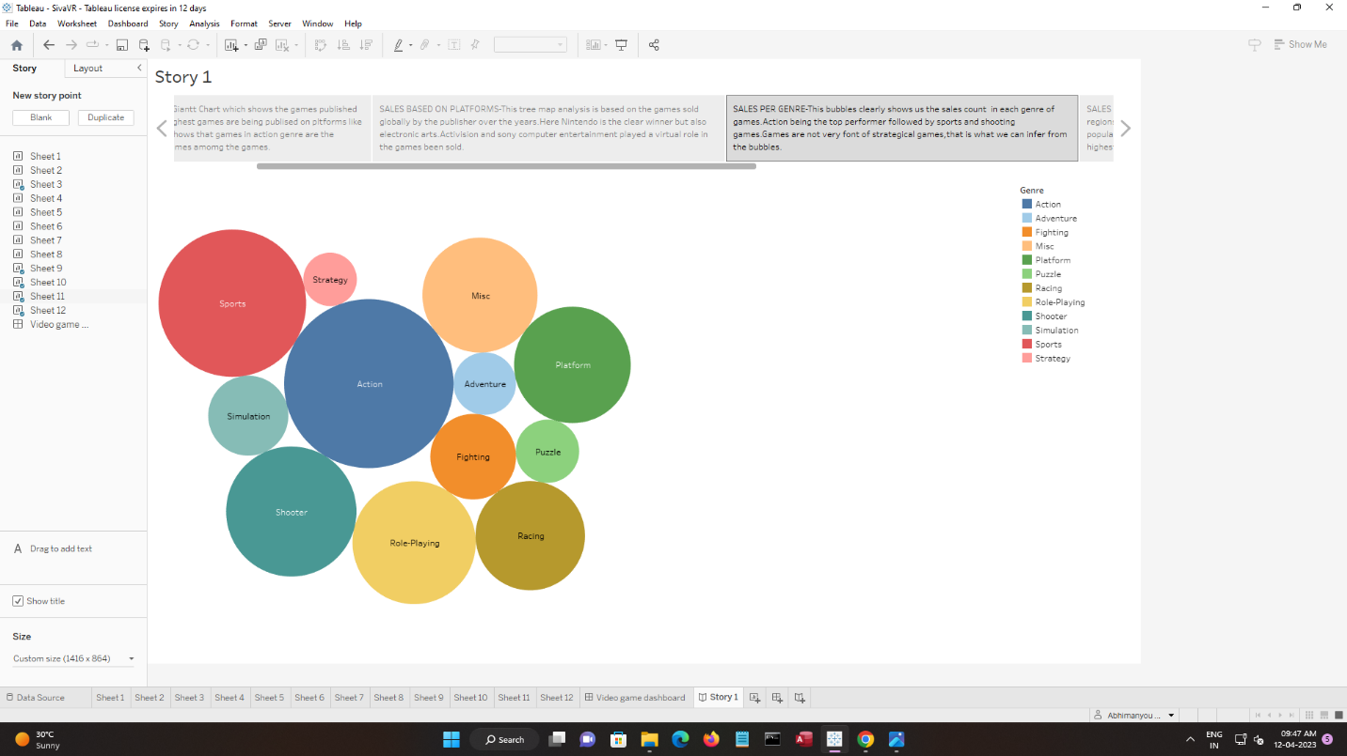

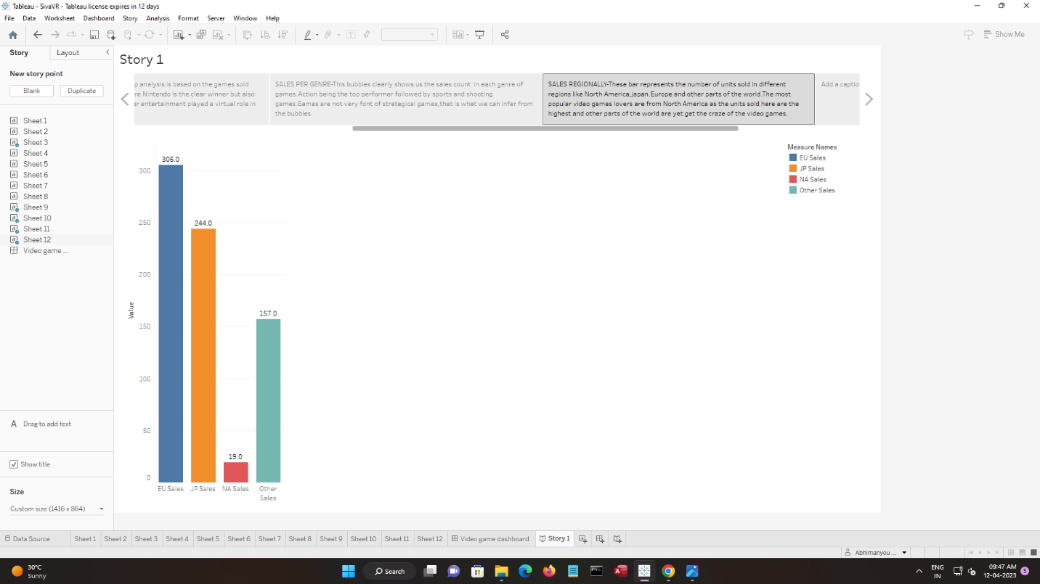

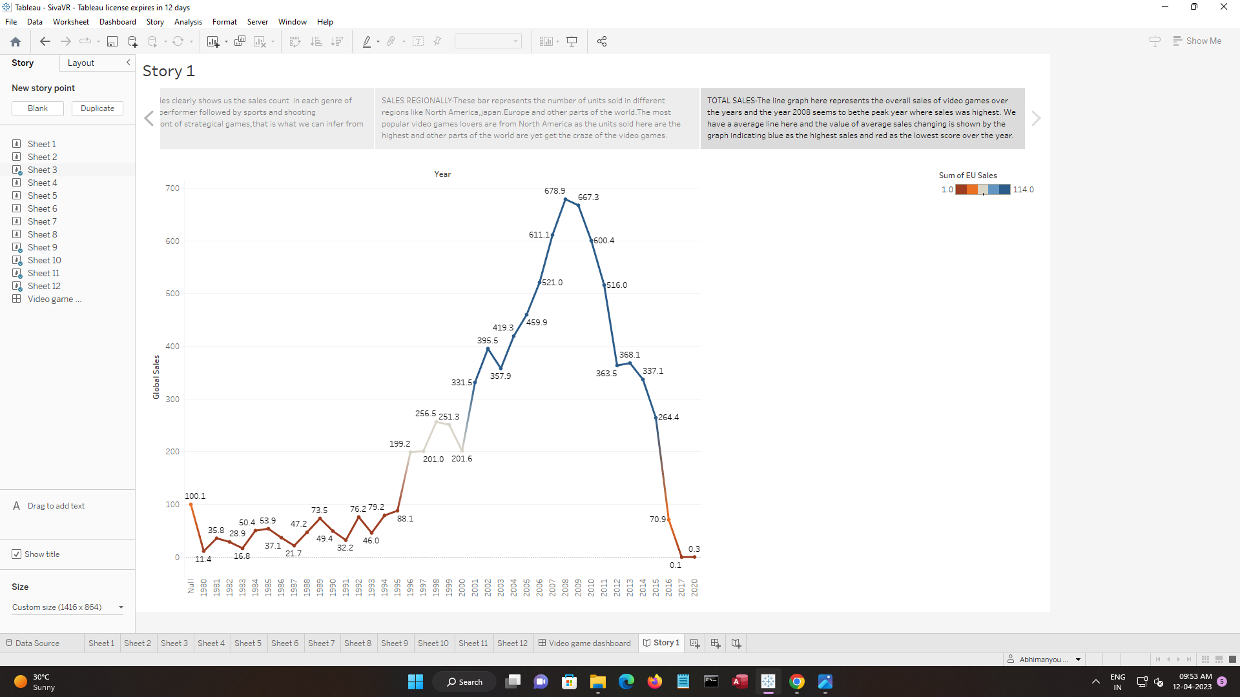

* The data source of this project contains a list of video games with sales greater than 100,000 copies. It was generated by a scrape of vgchartz.com.
* Once the data has been collected, it is typically analyzed using tableau. The results of the analysis can be used to identify trends and patterns in the market, and to make informed decisions about the development and marketing of video games.

4 ADVANTAGES & DISADVANTAGES

* It is an important part of the video game industry, as it helps to understand the needs and preferences of consumers and to identify opportunities for growth and innovation.
* Increased social interaction and connection through online multiplayer gaming.
* Increased awareness and representation of diverse groups in the gaming industry.
* Increased accessibility to gaming through mobile and online platforms. Increased use of gaming as a form of therapy or rehabilitation.
* Increased use of data analytics to track player behaviour and improve game design. Increased use of micro transactions and in-game purchases for additional revenue streams.

5 APPLICATIONS

* Video Game Industry Analysis: Insights and Forecast- by Research and Markets (2016). This report provides a comprehensive analysis of the global video game industry.
* This analysist will used for upcoming game developer to improve game coding according to the current trends.
* "Video Game Sales by Platform: A Comparative Analysis" by Newzoo (2017) – This report compares the sales of video games across different platforms, including consoles, PC, and mobile. It also includes data on the top-selling games for each platform and analyses trends in the industry.
* The gaming industries will use this data set analysis to increase there selling level and improve in demand.

1. CONCLUSION

* In this project the game dataset is separated to the different graphs, bar chart, pie chart etc., according to people sunder stand the dataset by seeing the chats and stories. In this project the 2010 is the highest game selling year in the dataset collection.
* The projects visualization/Graphs are given below

1.Sales in different region Analysis

2.Genre with rank Analysis

3. Total Sales Analysis

4. Top 5 publishers Analysis

5. Best 10 selling genres on platform Analysis

6. Top 10 EU selling video games Analysis

7. Top 10 Japan selling video games Analysis

8. Top 10 NA selling video games

1. FUTURE SCOPE

* The project contains the dataset for game in regions, genre, sales of games. But they want to collect the time of the game installed in the desired devices and must consider the feedback for increase in sale of game industries.
* The games will also be easily available to purchase.
* The monthly data will collect and must analysis for increase in the development of gaming industries.

1. APPENDIX

1. SOURCE CODE

Story :

<https://public.tableau.com/views/SivaVR/Story1?:language=enGB&publish=yes&:display_count=n&:origin=viz_share_link>

dashboard:

<https://public.tableau.com/views/SivaVR/Videogamedashboard?:language=en-GB&publish=yes&:display_count=n&:origin=viz_share_link>